1. Read dataset and extract into torch arrays

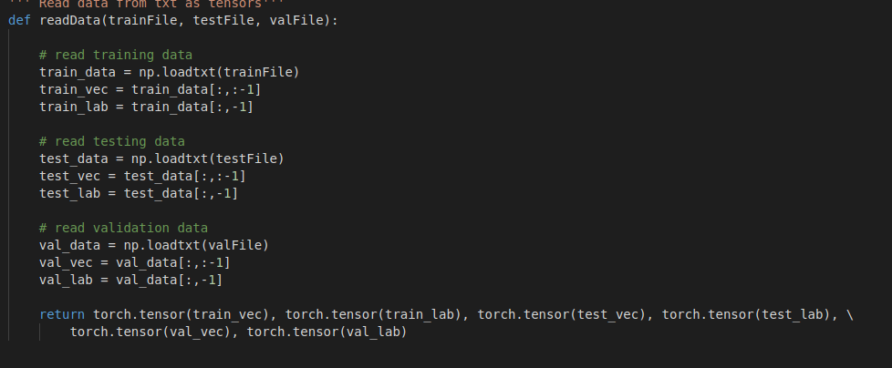

1. Data feature extraction

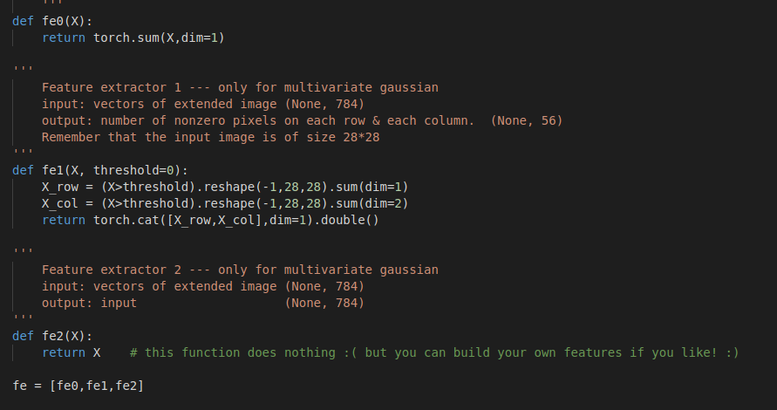

1. Calculate prior distribution of the labels



For each class we need to calculate the prior distribution , which number of samples per each class / total number of samples in the dataset

1. Define univariate distribution for each class

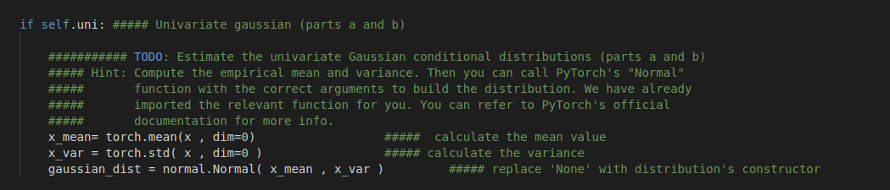

For each class we need to define a univariate normal distribution , for that we need to estimate the mean for each class and standard distribution of pixel values . After getting mean and std we can define torch normal distribution .

------- answers for question

9. b) priors [0.1000, 0.1000, 0.1000, 0.1000, 0.1000, 0.1000, 0.1000, 0.1000, 0.1000, 0.1000]

Distributions :

Normal(loc: 34603.86, scale: 8701.113166259835)

Normal(loc: 14856.785, scale: 4018.071207672236)

Normal(loc: 30153.155, scale: 7368.519008789313)

Normal(loc: 29007.875, scale: 7275.103133799002)

Normal(loc: 24494.485, scale: 6580.103868815217)

Normal(loc: 26235.545, scale: 7347.717952091822)

Normal(loc: 27274.915, scale: 7740.38679956041)

Normal(loc: 23157.6, scale: 6254.645443839379)

Normal(loc: 30372.085, scale: 7424.477760614838)

Normal(loc: 24421.865, scale: 6221.704678971569)

c) The classification accuracy is 0.194

1. Define multivariate distribution

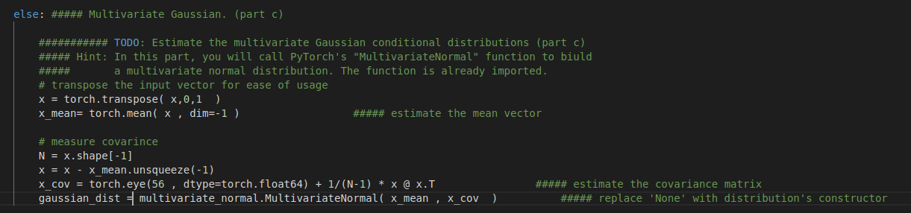

Define the mean vector for the 56 dimension feature array and define the covariance of the feature vector . using the mean and covariance define the multivariate normal distribution to model the vectors .

Multivariate model accuracy :

The classification accuracy is 0.832